Report for: | Cabinet
Date of Meeting: | 26 October 2023
Subject: | Strategic Performance Report Q1 2023-24
Key Decision: | No
Responsible Officer: | Alex Dewsnap, Managing Director
Portfolio Holder: | Cllr Stephen Greek, Portfolio Holder for Performance, Communications and Customer Experience
Exempt: | No
Decision subject to Call-in: | Yes
Wards affected: | All wards
Enclosures: | Appendix 1 – Strategic Performance Report  Appendix 2 – Corporate Scorecard

Section 1 – Summary and Recommendations
This report summarises Council and service performance for Quarter 1 against key measures and draws attention to areas requiring action.

Recommendations:
That
- Portfolio Holders continue to work with officers to achieve improvement against identified key challenges (Appendix 1)
- Cabinet notes the report and identifies any changes it wishes to see in future reports

Reason: (for recommendations)
To enable Cabinet to be informed of performance against key measures and to identify and assign corrective action where necessary.

Section 2 – Report

Introductory paragraph

Appendix 1 to this report addresses performance against the objectives and Flagship Actions in the Council’s corporate plan ‘Restoring Pride in Harrow’, arranged by the three priorities:

- A council that puts residents first
- A borough that is clean and safe
- A place where those in need are supported.

Options considered.
Whilst there is no legal requirement to formally report performance data, Cabinet’s terms of reference in the Constitution include overseeing strategic performance issues on a quarterly basis and it is considered best practice to provide a public report and have a public debate on performance. As such it is recommended to have formal, public reporting of performance to Cabinet.

Summary of Performance
Note that the status of both Flagship Actions and performance indicators is reported and summarised here as at the end of Q1, 30th June 2023. The status of some of these will have changed in the monthly monitoring since the end of Q1. For Cabinet Reporting, the quarterly position is shown, noting that there is ongoing monitoring which will be reflected in the next quarterly report.

Overall Performance at end of Quarter 1, June 30th 2023:

All Flagship Actions (FA)
*(note total is more than the original 24 FAs as some actions are split for reporting purposes)

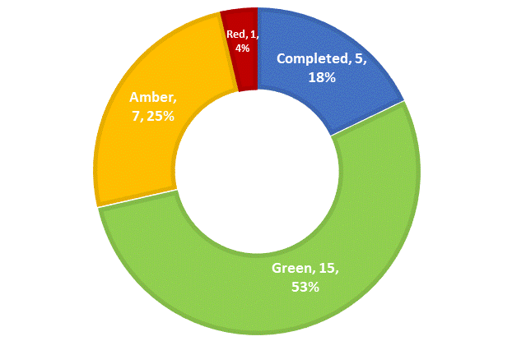

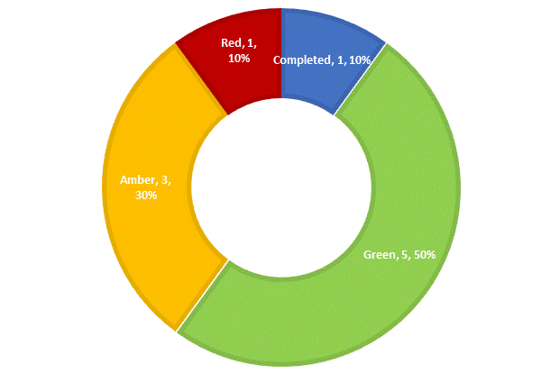
FA - Residents First FA – Clean & Safe FA – Supporting those in Need
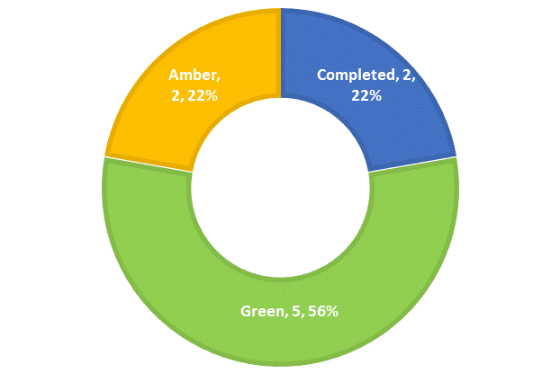

All Performance Indicators (PI)

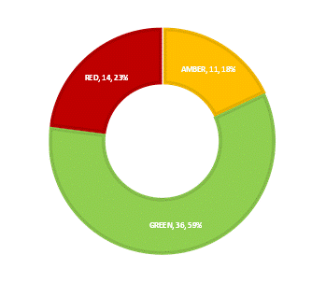

PI - Residents First PI - Clean & Safe PI - Supporting those in Need
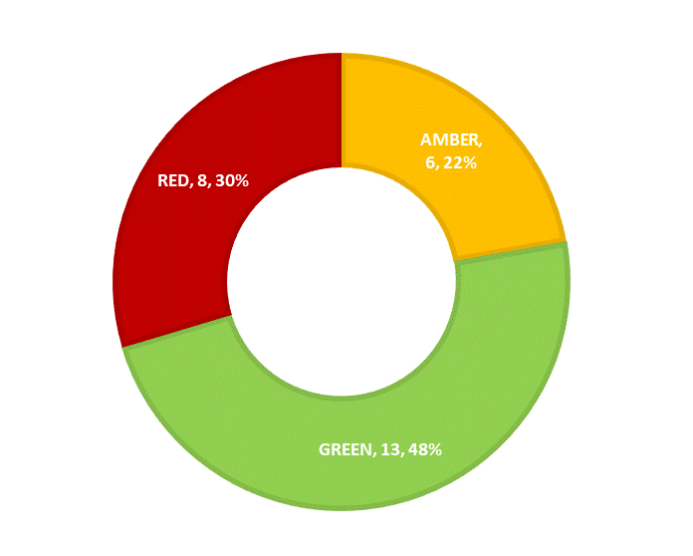
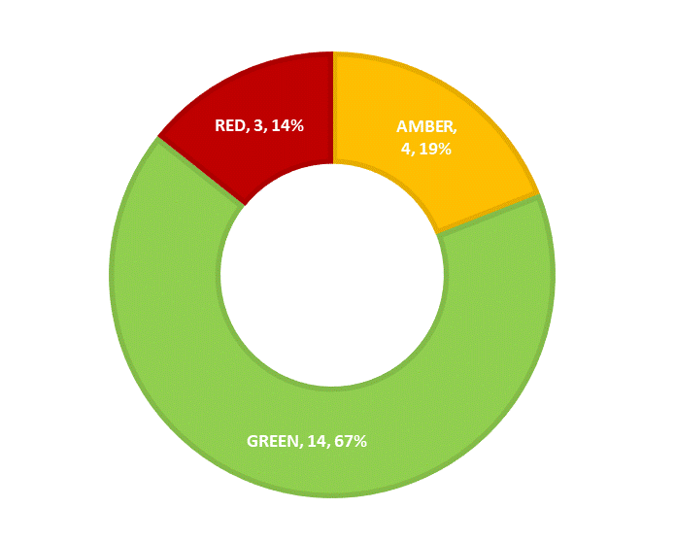
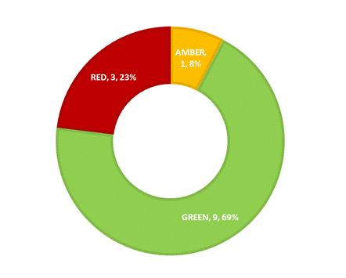

More detail on Q1 performance and Flagship Actions can be found in the appendices, along with a key to RAG (Red-Amber-Green) ratings.

Ward Councillors’ comments
Not applicable

Performance Issues

The report deals in detail with performance issues.

Data Protection Implications

Personal data is protected when reporting performance through aggregation of data, anonymisation and suppression of low numbers that might enable individuals to be identified.

Risk Management Implications
The risks arising from the Performance Report will be measured through the
Council’s Corporate and Directorate level Risk Registers.

Risks included on corporate or directorate risk registers?
Yes

Separate risk register in place? No

The relevant risks contained in the register are attached/summarized below.
N/A

The following key risks should be taken into account when agreeing the recommendations in this report:

Risk Description | Mitigations | RAG Status
Corporate performance information is not reported in a timely manner and this may prevent remedial action being taken promptly (where appropriate) in key areas | - Performance scorecards exist at service and Directorate level which include all the indicators in the Corporate Scorecard  - Managers receive real time data in critical areas e,g, outstanding assessments  - Service and Directorate level scorecards are considered in performance sessions with managers that occur soon after the period end – when the data becomes available, usually monthly.  - Information is available quickly and action is taken to address performance issues as they arise. | Green

Procurement Implications
None

Legal Implications
The Council has a duty under s.3 of the Local Government Act 1999 to make arrangements to secure continuous improvement in the way in which its functions are exercised, having regard to a combination of economy, efficiency and effectiveness. Draft guidance on compliance with this duty was published for consultation over the summer 2023. Whilst still in draft, the contents set out the Government’s expectations in terms of compliance.

The draft guidance refers to the role of the Office of Local Government whose objective is to increase transparency of performance in the local government sector. The guidance contains details on the characteristics of a well-functioning authority, which includes frequent monitoring, performance reporting and updating of the corporate and improvement plans, ensuring that plans are evidence based, current, realistic and enable performance to be measured, there should be alignment with the financial strategy, actual outcomes should be measured effectively and frequently interrogated, performance should be regularly reported to the public to ensure citizens are informed of the quality of services being delivered and there should be opportunities for resident and partner engagement in developing, monitoring and managing performance.

Financial Implications
There are no financial implications arising from this report.

Equalities implications / Public Sector Equality Duty
S.149 of the Equality Act 2010 requires public bodies to have due regard to the need to eliminate discrimination, harassment, victimisation, and any other conduct that is prohibited, advance equality of opportunity and foster good relations between persons who share a protected characteristic and those who do not. This requires the Council to collect, monitor and manage equality data and consider the impact of its decisions on different parts of the community. The Council should consider its equality duties in all aspects of its decision-making and has specific duties to publish equality objectives and information to demonstrate compliance with the s.149 duty.

Council Priorities

The performance report is arranged according to the 3 council priorities:

- A council that puts residents first

- A borough that is clean and safe

- A place where those in need are supported.

Section 3 - Statutory Officer Clearance
Statutory Officer: Sharon Daniels
Signed off by the Chief Financial Officer
Date: 4 October 2023
Statutory Officer: Sarah Wilson
Signed on behalf of the Monitoring Officer
Date: 29 September 2023
Chief Officer: Alex Dewsnap
Signed off by the Corporate Director
Date: 2 October 2023
Head of Procurement: Nimesh Mehta
Signed by the Head of Procurement
Date: 2 October 2023
Head of Internal Audit: Neale Burns
Signed on behalf of/by the Head of Internal Audit

Date: 2 October 2023

Has the Portfolio Holder(s) been consulted? Yes ☒

Mandatory Checks

Ward Councillors notified: No, as it impacts on all Wards

EqIA carried out: No

Not required for the quarterly performance report

Section 4 - Contact Details and Background Papers
Contact: David Harrington david.harrington@harrow.gov.uk 07714 089170
Background Papers: None
Call-in waived by the Chair of Overview and Scrutiny Committee: No

